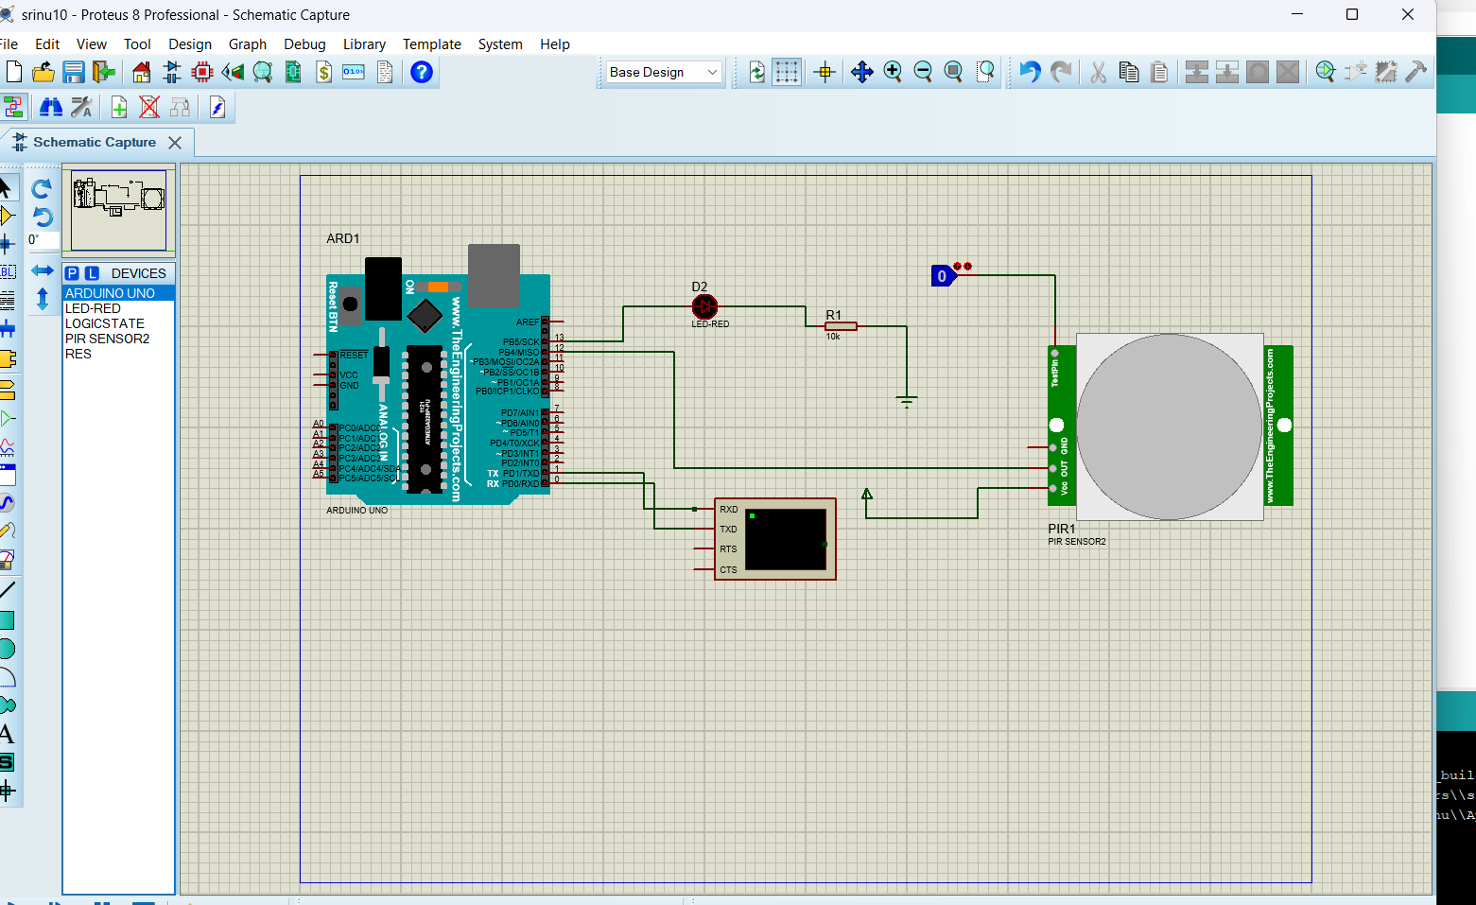
// PIR Motion Sensor with LED

const int Status = 13; // LED connected to Digital Pin 13
const int sensor = 12; // PIR sensor connected to Digital Pin 12

void setup() {
Serial.begin(9600);

pinMode(sensor, INPUT); // PIR sensor as input
pinMode(Status, OUTPUT); // LED as output
}

void loop() {
int state = digitalRead(sensor);

Serial.print("Sensor State: ");
Serial.println(state);

if (state == HIGH) {
digitalWrite(Status, HIGH);
Serial.println("Motion detected!");
} else {
digitalWrite(Status, LOW);
Serial.println("Motion absent!");
}

delay(1000); // Wait for 1 second
}
